

***DENTAL***

***CARE***

**E-Project Documentation**

**Teacher Name : MISS SYEDA IMAMA ALI**

**APTECH COMPUTER EDUCATION**

**HYDERABAD-1 PAKISTAN**

**Issue Date : 03-Dec-2023**

TABLE OF CONTENT

|  |  |  |
| --- | --- | --- |
| **S No** | **Contents** | **Page No** |
| 01 | Certificate | 3 |
| 02 | Acknowledgement | 4 |
| 03 | Project Report | 5 |
| 04 | Problem Definition | 6 |
| 05 | Customer Requirements Specification  (CRS) | 7 |
| 06 | Architecture Design of the Project | 9 |
| 07 | System Requirement | 10 |
| 08 | Task Sheet | 11 |
| 09 | Project Plan | 13 |
| 10 | Checklist of work Progress | 14 |
|  |  |  |
| 11 | Screen Shots | 15 |
| 12 | Source Code | 19 |

CERTIFICATE

This is to certify that

**HARMAN SHAIKH**

Has successfully Designed

DENTAL Care

Submitted by:

**HARMAN SHAIKH**

Date of Issue: 03-Dec-2023

**Authorized Signature:**

MISS SYEDA IMAMA ALI

ACKNOWLEDGEMENT

First and foremost, we would like to express our deep gratitude and most heartfelt thanks to almighty ALLAH for his blessings, for lightening up our heart with the torch of knowledge and for giving us the ability to complete this project.

We would like to thanks Aptech Worldwide and the team of E-Project for their generous support and clarifying the doubts regarding e-project. We would like to acknowledge the way of explanation which the team of e-project gave in e-project to make website and we are equally grateful to our teacher (Sir Amjad Ali) for giving us a moral support and guiding us different matters regarding project in all the time about the research and writing of this project.

We are greatly indebted to Aptech Worldwide, Miss Syeda Imama Ali, Faculty Members and ACE Hyderabad, Pakistan for encouragement and incessant help.

PROJECT REPORT

**BY:**

**HARMAN SHAIKH, ABDULLAH SHAIKH, ABDULLAH WARRAICH**

**Project Title : DENTAL CARE,**

**Members Name : HARMAN SHAIKH, ABDULLAH SHAIKH,ABDULLAH WARRAICH**

**Batch Code : 2307E**

**Start Date : 03- Dec-2023**

**End Date : 27-Dec-2023**

**Course : ACCP (CPISM)**

**Teacher : Miss Syeda Imama Ali**

**Center Manager : Sir Shoaib Ahmed**

**Center Academic Head : Sir Zubair Ahmed**

**Center Name : ACE Hyderabad-1, Pakistan**

Submitted as

E Project Documentation

**PROBLEM STATEMENT**

​​​​​​​​​​​​​​​​​​​​​​​​​​​​​​​​​​​​​​​​​​​​​​Dental or oral health is concerned with your teeth, gums and mouth. The goal is to prevent complications such as tooth decay (cavities) and gum disease and to maintain the overall health of your mouth.

## ​​​​​​​​​​​​​​​​​​​​​​​​​​​​​​​​​​​​​​​​​​​​​​A healthy mouth, free of infections, injuries and other problems with teeth and gums, is important in maintaining your overall health.

Although a different set of medical professionals focuses on dental health, they are still part of your regular health care team.

Disease and other conditions can affect your dental health and dental problems can affect other parts of your body. Failing to properly care for your oral health may lead to other health problems.

You can help prevent or minimize many oral health problems by regular preventive steps (brushing, flossing and so on) and regular visits to dental health professionals.

Hence to increase the awareness and provide all information about dental care , we are looking for developing a website “32smiles.com” based on the requirements mentioned below.

The website is to be developed for the Windows Platform using HTML5, JavaScript and Geolocation. The site should work well in all leading browsers including Chrome, IE, Firefox etc.

**Requirement Specification**

**The Web site is to be created based on the following requirements.**

1. **The home page to display the related images and couple latest information/researches in the field.**
2. **Also there should be a categorized menu with related sub menus.**
3. **Sample list of pages/menu options are as mentioned below**
   1. **Professional education: This mainly includes the education assistance for students and practitioners. This can have further categories like finding related courses, help documents, faculty resources, student resources, case studies etc**
   2. **Patient education: This should include general and necessary information for the patients suffering from any of the oral/dental issues.**
   3. **Research: This should include the latest research in the field. Necessary documents, videos etc (media library) is expected here.**
   4. **Products: As the name indicates it should include all the related products. Here sub categories can be done based on various types of products as tooth pastes , brushes, special products for kids, electrical accessories etc**
4. **There should be site map**
5. **Contact us page: contact us page here should list various dental professional’s contact details for further treatment / assistance/guidance. Their location should be displayed using GeoLocation API (eg. GoogleMaps).**
6. **Overall website should be user friendly**

PROJECT OBJECTIVE:

The Objective of this program is to give a sample project to work on real life

projects. These applications help you build a larger more robust application.

The objective is not to teach you JavaScript/Dreamweaver but to provide you with a

real life scenario and help you create basic applications using the tools.

You can revise the chapters before you start with the project.

This project is meant for students who have completed the module of

Dreamweaver. These programs should be done in the Lab sessions with assistance

of the faculty if required.

It is very essential that a student has a clear understanding of the subject. Students

should go through the project and solve the assignments as per requirements given.

Kindly get back to eProjects Team in case of any doubts regarding the application or

its objectives.

System Requirement:

|  |  |  |
| --- | --- | --- |
| **SR.No** | **Items** | **Description** |
| 01 | Operating System | Window XP, Win7 or win8 |
| 02 | Main Processor | Minimum 2ghz or better |
| 03 | Ram (Memory) | Minimum 512mb or better |
| 04 | Web Browser | Google Chrome or Firefox (Latest) |
| 05 | Software | Notepad/HTML editor/CoffeeCup  Angular / Angular JS / React / BootStrap  Dreamweaver / Figma  MS IE / Chrome / FireFox / Netscape /MS Edge |

TASK SHEET

|  |  |  |  |  |  |
| --- | --- | --- | --- | --- | --- |
| **Project Ref. No:** | | **Date of Preparation of Activity Plan:** | | | |
| SR.  No | Task | Actual  Start  Date: | Actual  Day: | Team  Mates  Names: | Status: |
| 01 | Planing | 03-Dec-2023 | 1 | Harman,  Abdullah | YES |
| 02 | Data  Collection | 04-Dec-2023 | 1 | Harman,  Abdullah | YES |
| 03 | Designing  Home  Page | 10-Dec-2023 | 4 | Harman,  Abdullah | YES |
| 04 | Linking | 12-Dec-2023 | 9 | Harman,  Abdullah | YES |
| 05 | Check  Links | 13-Dec-2023 | 2 | Harman,  Abdullah | YES |
| 06 | Finalizing | 20-Dec-2023 | 3 | Harman,  Abdullah | YES |
| 07 | Testing | 22-Dec-2023 | 2 | Harman,  Abdullah | YES |
| 08 | Documentation | 23-Dec-2023 | 1 | Harman,  Abdullah | YES |
| 09 | Uploading | 26-Dec-2023 | 2 | Harman,  Abdullah,  Abdullah SH | YES |

PROJECT PLAN

* Website is able to execute quickly.
* The color scheme of the site looks attractive.
* The collection of data is authentic and taken by the most popular product websites.
* There is authentic information of facilities products with their specifications.
* Background is different to main page.
* The HOME is well prepared exactly for the same page as user clicks on the link..
* A visitor can also view the individual image of our every gallery.

CHECK LIST OF WORK PROGRESS

|  |  |  |
| --- | --- | --- |
| **SR.No** | **Aspect Tested** | **Remarks** |
| 01 | Data Collection | **yes** |
| 02 | Designing Home Page | **yes** |
| 05 | Linking The Pages | **yes** |
| 06 | Finalization | **Yes** |
| 08 | Tasting The Site | **Yes** |
| 09 | Documentation | **yes** |

SCREEN SHOTS

Home-page-1

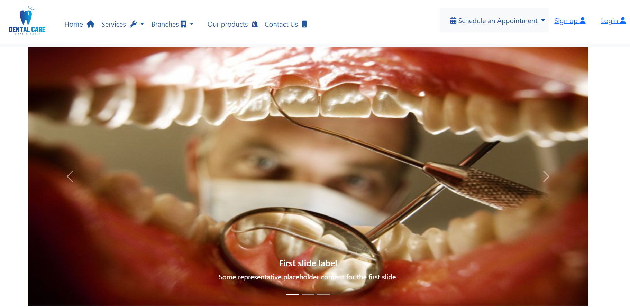

Home-page-2

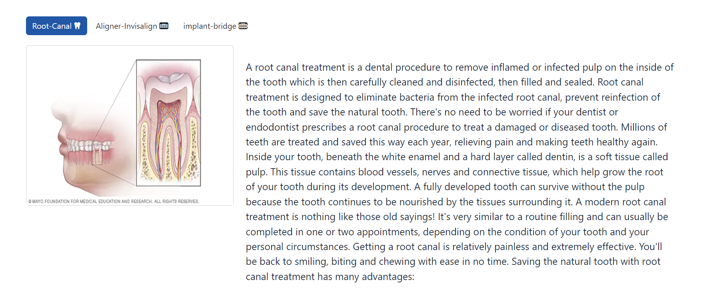

Home-page-3

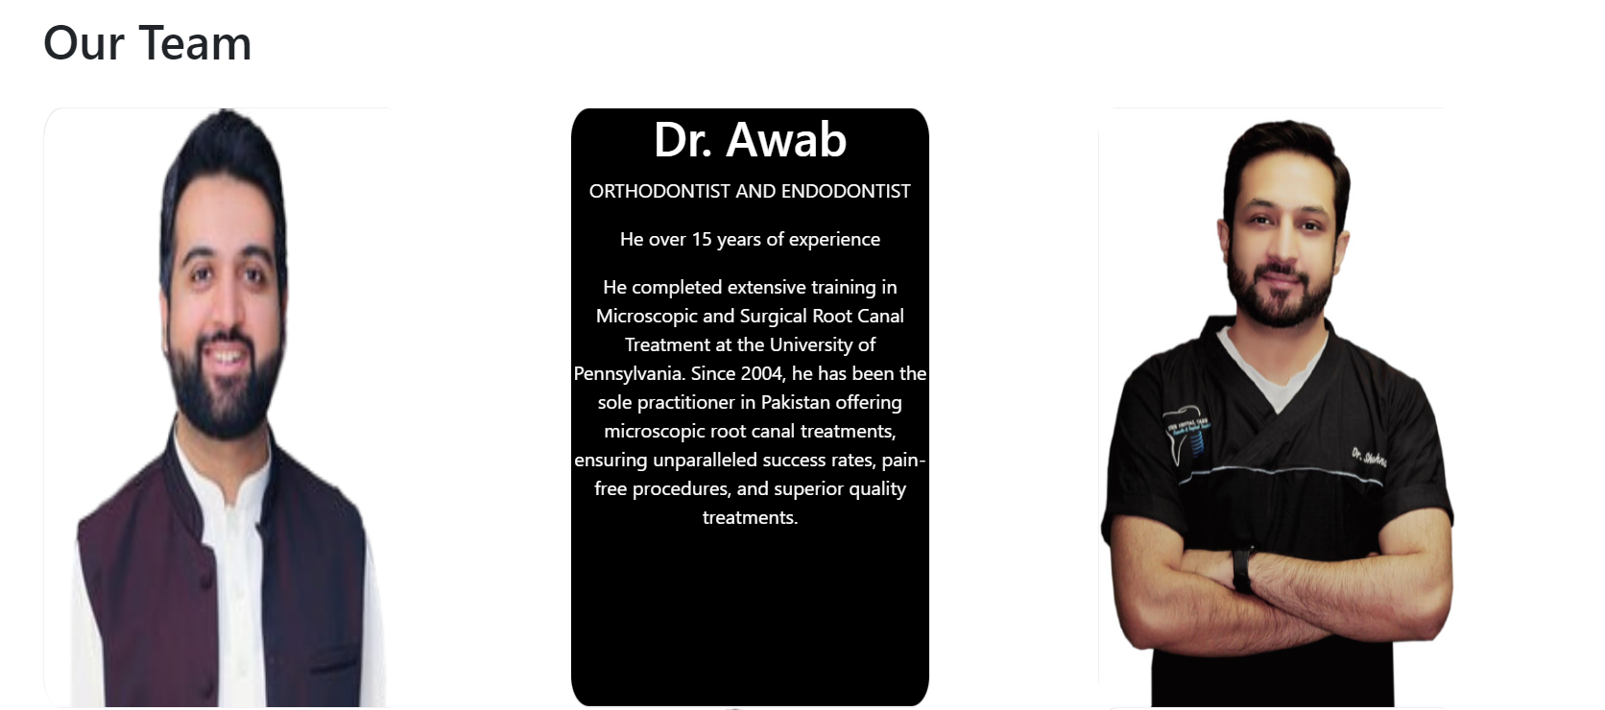

Home-page-4

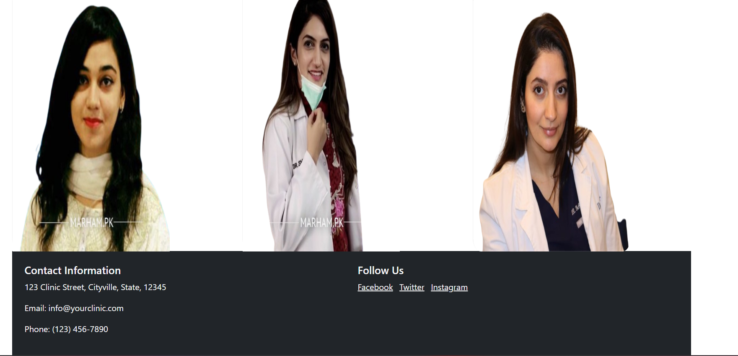

Service page 1

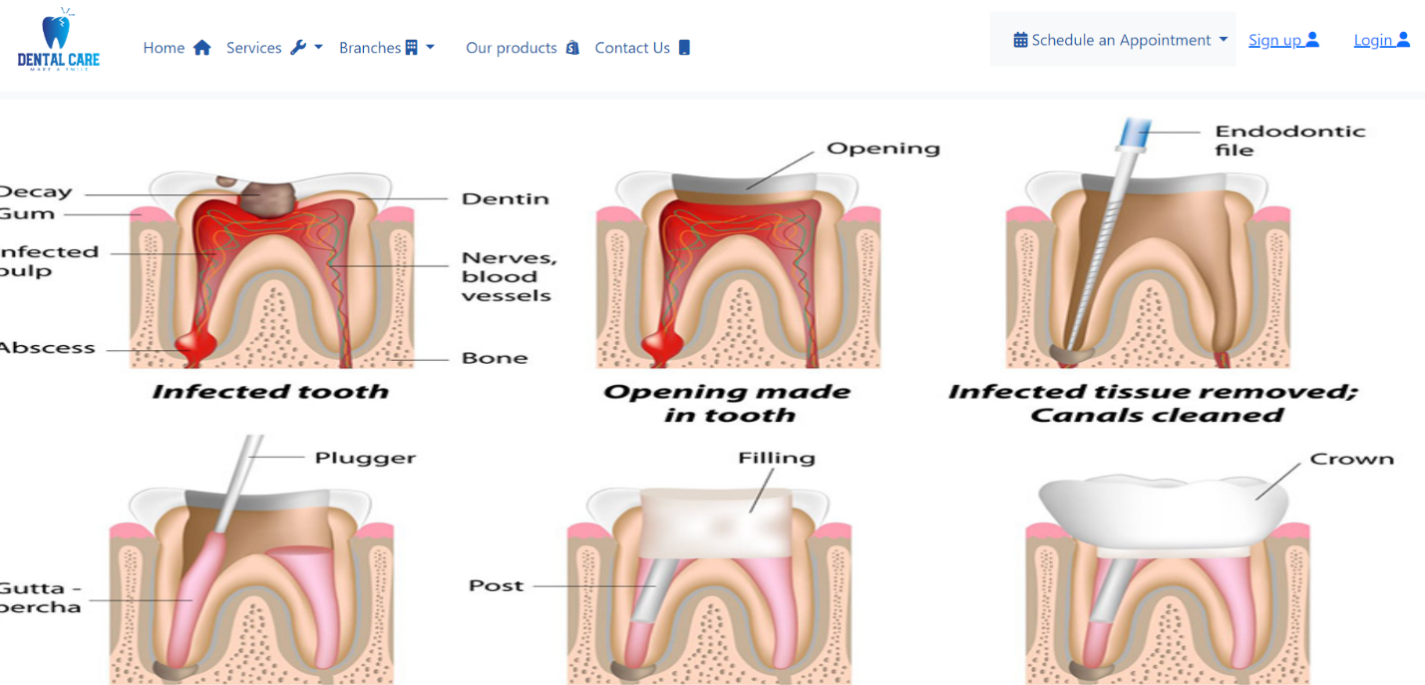

Service Page 2

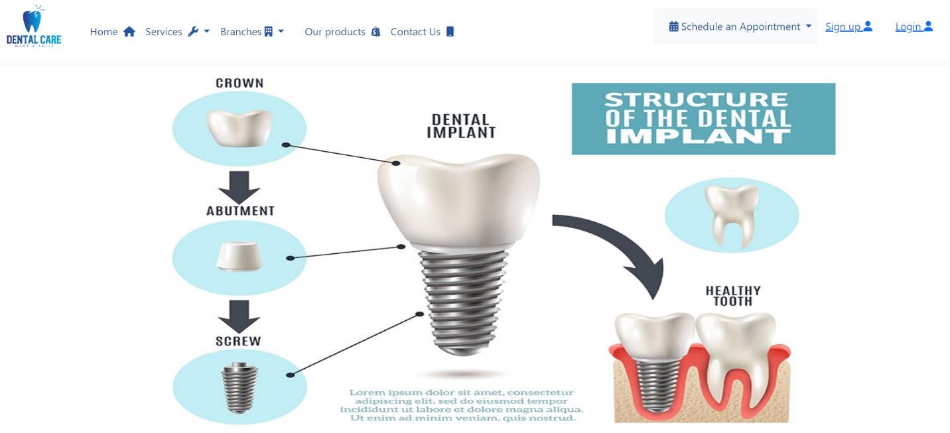

Contact-us

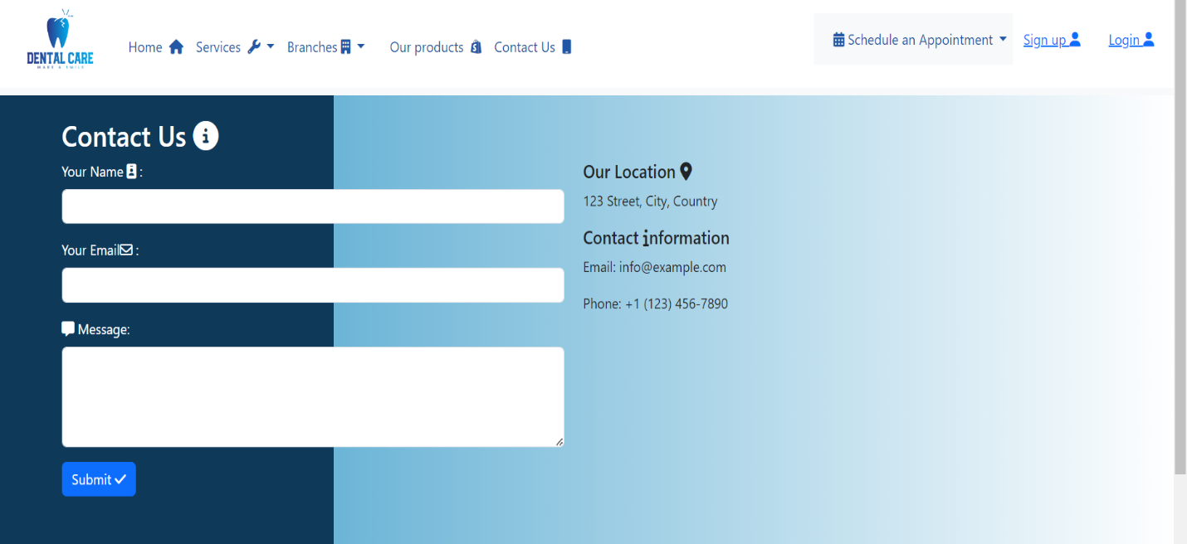

Product-page

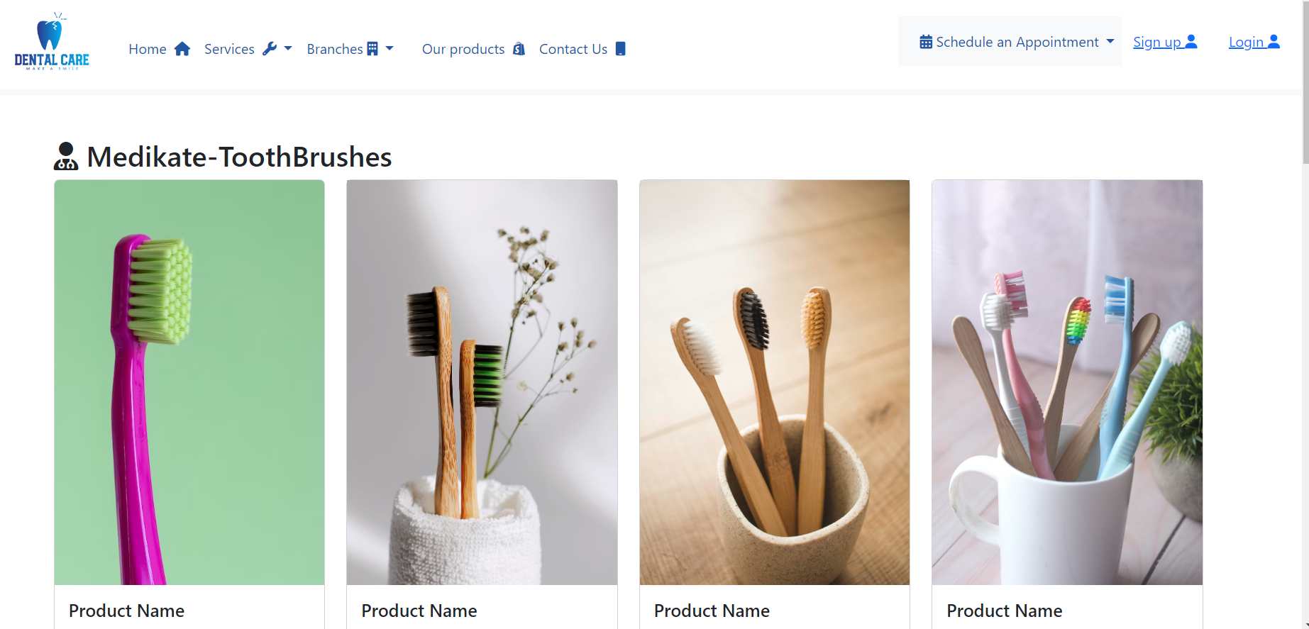

Source code

<!DOCTYPE html>

<html lang="en">

<head>

  <meta charset="UTF-8">

  <meta name="viewport" content="width=device-width, initial-scale=1.0">

  <link rel="stylesheet" href="https://stackpath.bootstrapcdn.com/bootstrap/4.3.1/css/bootstrap.min.css">

  <link rel="stylesheet" href="bootstrap-5.3.2-dist/css/bootstrap.min.css">

  <link rel="stylesheet" href="https://cdnjs.cloudflare.com/ajax/libs/font-awesome/6.5.1/css/all.min.css">

  <script src="jquery-3.7.1.min.js"></script>

  <link rel="stylesheet" href="wibsite.css">

  <title>Home page</title>

</head>

<body>

*<!-- navbar start -->*

  <nav class="navbar navbar-expand-lg bg-body-tertiary">

    <div class="container-fluid">

      <a class="navbar-brand" href="#"></a> <img src="Screenshot 2023-12-05 183119.png" alt="" style="width: 160px;">

      <button class="navbar-toggler" type="button" data-bs-toggle="collapse" data-bs-target="#navbarSupportedContent"

        aria-controls="navbarSupportedContent" aria-expanded="false" aria-label="Toggle navigation">

        <span class="navbar-toggler-icon"></span>

      </button>

      <div class="collapse navbar-collapse" id="navbarSupportedContent">

        <ul class="navbar-nav me-auto mb-2 mb-lg-0 mt-3">

          <li class="nav-item">

            <a class="nav-link " aria-current="page" href="#">Home &nbsp;<span class="fa fa-home"></span></a>

          </li>

          <li class="nav-item dropdown">

            <a class="nav-link dropdown-toggle" href="#" role="button" data-bs-toggle="dropdown" aria-expanded="false">

              Services &nbsp;<span class="fa fa-wrench"></span>

            </a>

            <ul class="dropdown-menu">

              <li><a class="dropdown-item" href="roottreatment copy.html">Root-Canal-Treatment <i class="fa-solid fa-toolbox"></i></a></li>

              <li><a class="dropdown-item" href="implants treatment.html">implant-bridge-Treatment <i class="fa-solid fa-toolbox"></i></a></li>

              <li>

                <hr class="dropdown-divider">

              </li>

              <li><a class="dropdown-item" href="#"> More <i class="fa-solid fa-info"></i></a></li>

            </ul>

          </li>

          <li class="nav-item dropdown">

            <a class="nav-link dropdown-toggle" href="#" role="button" data-bs-toggle="dropdown" aria-expanded="false">

              Branches&nbsp;<span class="fa fa-building"></span>

            </a>

            <ul class="dropdown-menu">

              <li><a class="dropdown-item" data-bs-toggle="modal" data-bs-target="#modalId">HYDERABAD SADAR <i class="fa-solid fa-location-dot"></i></a></li>

              <li><a class="dropdown-item" data-bs-toggle="modal" data-bs-target="#modalId2">KARACHI DHA <i class="fa-solid fa-location-dot"></i></a></li>

              <li>

                <hr class="dropdown-divider">

              </li>

              <li><a class="dropdown-item" href="#">More <i class="fa-solid fa-info"></i></a></li>

            </ul>

          </li>

          <li class="nav-item">

            <a class="nav-link " aria-disabled="true"></a>

          </li>

            <a class="nav-link" href="product.html">Our products &nbsp;<i class="fa-brands fa-shopify"></i></a>

          </li>

          <li class="nav-item">

            <a class="nav-link" href="c.html">Contact Us &nbsp;<span class="fa fa-mobile"></span></a>

          </li>

          <li class="nav-item">

            <a class="nav-link " aria-disabled="true"></a>

          </li>

        </ul>

        <nav class="navbar navbar-expand-lg navbar-light bg-light">

          <a class="navbar-brand" href="#"></a>

          <ul class="navbar-nav ml-auto" style="color: #2157A5;">

            <li class="nav-item dropdown schedule-dropdown">

              <a class="nav-link dropdown-toggle " href="#" id="navbarDropdown" role="button" data-toggle="dropdown" aria-haspopup="true" aria-expanded="false" style="color: #2157A5;">

                <i class="fa-solid fa-calendar-days"></i> Schedule an Appointment

               </a>

              <div class="dropdown-menu" aria-labelledby="navbarDropdown">

                <p class="dropdown-item">Monday: 09:30AM-08:00PM</p>

                <p class="dropdown-item">Tuesday: 09:30AM-08:00PM</p>

                <p class="dropdown-item">Wednesday:09:30AM-08:00PM</p>

                <p class="dropdown-item">Thursday: 09:30AM-08:00PM</p>

                <p class="dropdown-item">Friday: 09:30AM-08:00PM</p>

                <p class="dropdown-item">Saturday: 09:30AM-08:00PM</p>

                <p class="dropdown-item">Sunday: CLOSED</p>

              </div>

            </li>

          </ul>

        </nav>

        <form class="d-flex justify-content-between  " style="gap: 10px;" ;>

          <button class="btn btn--primary"> <a href="Signup.html">Sign up <i class="fa-solid fa-user"></i></a> </button>

          <button class="btn btn--primary"> <a href="Login.html"> Login  <i class="fa-solid fa-user"></i></a> </button>

        </form>

      </div>

    </div>

  </nav>

*<!-- navbar end -->*

*<!-- slid start -->*

  <div class="container ">

    <div id="carouselExampleCaptions" class="carousel slide">

      <div class="carousel-indicators">

        <button type="button" data-bs-target="#carouselExampleCaptions" data-bs-slide-to="0" class="active"

          aria-current="true" aria-label="Slide 1"></button>

        <button type="button" data-bs-target="#carouselExampleCaptions" data-bs-slide-to="1"

          aria-label="Slide 2"></button>

        <button type="button" data-bs-target="#carouselExampleCaptions" data-bs-slide-to="2"

          aria-label="Slide 3"></button>

      </div>

      <div class="carousel-inner">

        <div class="carousel-item active">

          <img src="often-visit-dentist.jpg" class="d-block w-100" alt="..." height="600px">

          <div class="carousel-caption d-none d-md-block">

            <h5>First slide label</h5>

            <p>Some representative placeholder content for the first slide.</p>

          </div>

        </div>

        <div class="carousel-item">

          <img src="https://fermeliadental.com/wp-content/uploads/2019/05/benefits-of-regular-dental-visits.jpeg" class="d-block w-100" alt="..." height="600px">

          <div class="carousel-caption d-none d-md-block">

            <h5>Second slide label</h5>

            <p>Some representative placeholder content for the second slide.</p>

          </div>

        </div>

        <div class="carousel-item">

          <img src="https://healthpoint.ae/media/z1jkm2k2/dentistry-2.jpg?anchor=center&mode=crop&width=630&height=408&rnd=133016639692600000" class="d-block w-100" alt="..."

            height="600px">

          <div class="carousel-caption d-none d-md-block">

            <h5>Third slide label</h5>

            <p>Some representative placeholder content for the third slide.</p>

          </div>

        </div>

      </div>

      <button class="carousel-control-prev" type="button" data-bs-target="#carouselExampleCaptions"

        data-bs-slide="prev">

        <span class="carousel-control-prev-icon" aria-hidden="true"></span>

        <span class="visually-hidden">Previous</span>

      </button>

      <button class="carousel-control-next" type="button" data-bs-target="#carouselExampleCaptions"

        data-bs-slide="next">

        <span class="carousel-control-next-icon" aria-hidden="true"></i></span>

        <span class="visually-hidden">Next</span>

      </button>

    </div>

  </div>

*<!-- slid end -->*

*<!-- Card start -->*

  <br>

  <br>

  <div class="container">

*<!-- row start -->*

    <button class="btn " onclick="root()" id="rr" style="color: white; background-color: #2157A5;">Root-Canal <i class="fa-solid fa-tooth"></i> </button>

    <button class="btn " onclick="align()" id="aa">Aligner-Invisalign <i class="fa-solid fa-teeth"></i></button>

    <button class="btn " onclick="dental()" id="dd">implant-bridge <i class="fa-solid fa-teeth-open"></i></button>

    <div class="row" id="a">

      <div class="col-lg-4 pt-20">

        <div class="card card1"><img src="https://www.mayoclinic.org/-/media/kcms/gbs/patient-consumer/images/2013/11/19/10/13/de00010-overview-of-root-canal-treatment.jpg" alt="" height="300px">

          <button class="btn-card">Read More</button>

        </div>

      </div>

      <div class="col-lg-8 pt-20 mt-5">

        <p class="text">A root canal treatment is a dental procedure to remove inflamed or infected pulp on the inside of the tooth which is then carefully cleaned and disinfected, then filled and sealed. Root canal treatment is designed to eliminate bacteria from the infected root canal, prevent reinfection of the tooth and save the natural tooth.

          There's no need to be worried if your dentist or endodontist prescribes a root canal procedure to treat a damaged or diseased tooth. Millions of teeth are treated and saved this way each year, relieving pain and making teeth healthy again.

Inside your tooth, beneath the white enamel and a hard layer called dentin, is a soft tissue called pulp. This tissue contains blood vessels, nerves and connective tissue, which help grow the root of your tooth during its development. A fully developed tooth can survive without the pulp because the tooth continues to be nourished by the tissues surrounding it.

A modern root canal treatment is nothing like those old sayings! It's very similar to a routine filling and can usually be completed in one or two appointments, depending on the condition of your tooth and your personal circumstances. Getting a root canal is relatively painless and extremely effective. You'll be back to smiling, biting and chewing with ease in no time.

Saving the natural tooth with root canal treatment has many advantages:

        </p>

      </div>

    </div>

*<!-- row start  -->*

    <div class="row" style="display: none;" id="b">

      <div class="col-lg-4 pt-20">

        <div class="card card1"><img src="https://clovedental.in/wp-content/uploads/2020/11/Aligner-Invisalign.jpg" alt="" height="300px">

          <button class="btn-card">Read More</button>

        </div>

      </div>

      <div class="col-lg-8 pt-20 mt-5">

        <p class="text">Everybody wants a great smile, but a lot of us need help getting there. More and more people are having success with clear orthodontic devices called aligners.

          Braces use brackets connected by wires to encourage teeth to move. Aligners are a series of tight-fitting custom-made mouthpieces that slip over the teeth. Invisalign is the largest producer of clear aligners, but it’s not the only brand. Others include Clear Correct, Inman Aligner, and Smart Moves.

          Clear (or "invisible") aligners aren't for everyone. Your orthodontist or dentist will help you decide what’s best for you. Ask them if they have experience treating people with aligners. Get references or before-and-after images of their patients. Learn more about FDA-approved teeth aligners.

          Can anyone get invisible teeth aligners?

          Because the invisible aligners are custom-built for a tight fit, they are best for adults or teens. Straightening a child’s teeth is more complicated. Young people, and their mouths, are still growing and developing; the doctor must think about this when setting up treatment.</p>

      </div>

*<!-- row end  -->*

*<!-- row start -->*

    </div>

    <div class="row" style="display: none;" id="c">

      <div class="col-lg-4 pt-20">

        <div class="card card1"><img src="https://singingriverdentistry.com/tpn/gen/IMG-dental-implants-perio-GettyImages-931130140.jpg" alt="" height="300px">

nt-brid

          <button class="btn-card">Read More</button>

        </div>

      </div>

      <div class="col-lg-8 pt-20 mt-5">

        <p class="text">An implant-supported bridge is similar to a traditional bridge, but it rests atop dental implants instead of natural teeth. Dental implants are small threaded posts that replace missing teeth roots. Before attaching a bridge to dental implants, your implants must fully integrate (fuse) with your jawbone.

          An implant bridge uses dental implants placed in the patient’s jawbone as a base. The restorations are the visible portion on the top and replace the teeth. These can preserve the nearby teeth and preserve the jawbone. Plus, the implant bridges can maintain the shape of the patient’s smile.

Maintaining the shape of one's smile can prevent future complications. If the teeth are missing, an implant bridge is a good option. A removable bridge attaches to the nearby teeth and can be removed to be cleaned. However, an implant bridge attaches to the implants in the jawbone. This offers a permanent solution that the patient does not have to worry about. These implants act and look like natural teeth.

        </p>

      </div>

    </div>

*<!-- row end -->*

    <br>

    <div class="team">

    <h1>Our Team </h1 >

      </div>

    <br>

    <div class="row">

      <div class="col-lg-4">

    <div class="flip-card">

      <div class="flip-card-inner">

        <div class="flip-card-front">

          <img src="1592546910_nouman-removebg-preview.png" alt="Avatar" style="width:300px;height:500px; border-radius: 5%;">

        </div>

        <div class="flip-card-back">

          <h1>Dr. Muhammad Nouman Anjum. </h1>

          <p>Physician</p>

          <p>General Physician, Family Physician, Hypertension Specialist, Diabetologist

            M.B.B.S., Certified Diabetologist , Certified Hypertension Specialist</p>

        </div>

      </div>

    </div>

    </div>

    <div class="col-lg-4">

    <div class="flip-card">

      <div class="flip-card-inner">

        <div class="flip-card-front">

          <img src="001-e1609587778122-removebg-preview.png" alt="Avatar" style="width:300px;height:500px;">

        </div>

        <div class="flip-card-back">

          <h1>Dr. Awab</h1>

          <p>ORTHODONTIST AND ENDODONTIST</p>

          <p>He over 15 years of experience </p>

          <p> He completed extensive training in Microscopic and Surgical Root Canal Treatment at the University of Pennsylvania. Since 2004, he has been the sole practitioner in Pakistan offering microscopic root canal treatments, ensuring unparalleled success rates, pain-free procedures, and superior quality treatments.</p>

        </div>

      </div>

    </div>

    </div>

    <div class="col-lg-4">

    <div class="flip-card">

      <div class="flip-card-inner">

        <div class="flip-card-front">

          <img src="Dr.Shahnawaz-bds-removebg-preview-1.jpg" alt="Avatar" style="width:300px;height:500px;">

        </div>

        <div class="flip-card-back">

          <h1>Dr. Shahnawaz Ahmed</h1>

          <p>Dentist</p>

          <p>Dr. Shahnawaz Ahmed

            Dentist

            Islamabad

            Qualifications:

            BDS

            RDS

            MCPS (Periodontology) PGT

            Member American Dental Association

            C- Implant & C- Perio Certification

            </p>

        </div>

      </div>

    </div>

    </div>

    </div>

    <div class="row">

      <div class="col-lg-4">

    <div class="flip-card">

      <div class="flip-card-inner">

        <div class="flip-card-front">

          <img src="dr-areeba-rehman-general-physician-karachi-38_450X450-removebg-preview.png" alt="Avatar" style="width:300px;height:500px;">

        </div>

        <div class="flip-card-back">

          <h1>JDr. Areeba Rehman</h1>

          <p> General Physician</p>

          <p>

            MBBS

            General Practitioner

            314 Reviews

            2 Yrs Experience</p>

        </div>

      </div>

    </div>

    </div>

    <div class="col-lg-4">

    <div class="flip-card">

      <div class="flip-card-inner">

        <div class="flip-card-front">

          <img src="dr-shireen-zubaida-dentist-lahore-41_450X450-removebg-preview.png" alt="Avatar" style="width:300px;height:500px;">

        </div>

        <div class="flip-card-back">

          <h1>Dr. Shireen Zubaida</h1>

          <p>

            Dentist

            </p>

          <p>

            BDS, FCPS-1

            General Practitioner

            4 Reviews

            3 Yrs Experience

            BDS, FCPS-1

            General Practitioner

            4 Reviews

            3 Yrs Experience</p>

        </div>

      </div>

    </div>

    </div>

    <div class="col-lg-4">

      <div class="flip-card">

        <div class="flip-card-inner">

          <div class="flip-card-front">

            <img src="dentistry-in-ajax-dr-hajer-al-tayeb-removebg-preview.png" alt="Avatar" style="width:300px;height:500px; border-radius: 5%;">

          </div>

          <div class="flip-card-back">

            <h1>Dr. Hajer Al Tayeb</h1>

            <p>Dentist</p>

            <p>She over 10 years of experience in the dental field</p>

            <p>she also strives to provide the most positive dental experience she can offer.</p>

          </div>

        </div>

      </div>

      </div>

    </div>

*<!-- <footer> start -->*

    <footer class="bg-dark text-light p-4">

      <div class="containerfooter">

        <div class="row">

          <div class="col-md-6">

            <h5>Contact Information</h5>

            <p>123 Clinic Street, Cityville, State, 12345</p>

            <p>Email: info@yourclinic.com</p>

            <p>Phone: (123) 456-7890</p>

          </div>

          <div class="col-md-6">

            <h5>Follow Us</h5>

            <ul class="list-inline">

              <li class="list-inline-item"><a href="#" class="text-light">Facebook</a></li>

              <li class="list-inline-item"><a href="#" class="text-light">Twitter</a></li>

              <li class="list-inline-item"><a href="#" class="text-light">Instagram</a></li>

            </ul>

          </div>

        </div>

      </div>

    </footer>

*<!-- footer end -->*

    <script>

      function root() {

        document.getElementById('rr').style.backgroundColor = '#2157A5';

        document.getElementById('rr').style.color = 'white';

        document.getElementById('aa').style.backgroundColor = 'white';

        document.getElementById('aa').style.color = '#2157A5';

        document.getElementById('dd').style.backgroundColor = 'white';

        document.getElementById('dd').style.color = '#2157A5';

        $('#a').show(2000);

        $('#b').hide(3000);

        $('#c').hide(3000);

      }

      function align() {

        document.getElementById('aa').style.backgroundColor = '#2157A5';

        document.getElementById('aa').style.color = 'white';

        document.getElementById('dd').style.backgroundColor = 'white';

        document.getElementById('dd').style.color = '#2157A5';

        document.getElementById('rr').style.backgroundColor = 'white';

        document.getElementById('rr').style.color = '#2157A5';

        $('#a').hide(3000);

        $('#b').show(2000);

        $('#c').hide(3000);

      }

      function dental() {

        document.getElementById('dd').style.backgroundColor = '#2157A5';

        document.getElementById('dd').style.color = 'white';

        document.getElementById('aa').style.backgroundColor = 'white';

        document.getElementById('aa').style.color = '#2157A5';

        document.getElementById('rr').style.backgroundColor = 'white';

        document.getElementById('rr').style.color = '#2157A5';

        $('#a').hide(3000);

        $('#b').hide(3000);

        $('#c').show(2000);

      }

    </script>

*<!-- Modal trigger button -->*

*<!-- Modal Body -->*

*<!-- if you want to close by clicking outside the modal, delete the last endpoint:data-bs-backdrop and data-bs-keyboard -->*

    <div class="modal fade" id="modalId" tabindex="-1" data-bs-backdrop="static" data-bs-keyboard="false" role="dialog"

      aria-labelledby="modalTitleId" aria-hidden="true">

      <div class="modal-dialog modal-dialog-scrollable modal-dialog-centered modal-sm" role="document">

        <div class="modal-content">

          <div class="modal-header">

            <h5 class="modal-title" id="modalTitleId">

              Hyderabad Sadder Location

            </h5>

            <button type="button" class="btn-close" data-bs-dismiss="modal" aria-label="Close"></button>

          </div>

          <div class="modal-body"><iframe

              src="https://www.google.com/maps/embed?pb=!1m18!1m12!1m3!1d3605.1314599314032!2d68.34923897516933!3d25.36691027760219!2m3!1f0!2f0!3f0!3m2!1i1024!2i768!4f13.1!3m3!1m2!1s0x394c71a0a8e8c7af%3A0x736adb2217d8f01e!2sDental%20Clinic!5e0!3m2!1sen!2s!4v1702560609477!5m2!1sen!2s"

              width="270" style="border:0;" allowfullscreen="" loading="lazy"

              referrerpolicy="no-referrer-when-downgrade"></iframe></div>

          <div class="modal-footer">

            <button type="button" class="btn btn-secondary" data-bs-dismiss="modal">

              Close

            </button>

            <button type="button" class="btn btn-primary "><a href="https://maps.app.goo.gl/EFfgJxVYHv8Atq6h6">Go</a>

            </button>

          </div>

        </div>

      </div>

    </div>

*<!-- Optional: Place to the bottom of scripts -->*

    <script>

*// const myModal = new bootstrap.Modal(*

*//   document.getElementById("modalId"),*

*//   options,*

*// );*

    </script>

*<!-- Modal Body -->*

*<!-- if you want to close by clicking outside the modal, delete the last endpoint:data-bs-backdrop and data-bs-keyboard -->*

    <div class="modal fade" id="modalId2" tabindex="-1" data-bs-backdrop="static" data-bs-keyboard="false" role="dialog"

      aria-labelledby="modalTitleId" aria-hidden="true">

      <div class="modal-dialog modal-dialog-scrollable modal-dialog-centered modal-sm" role="document">

        <div class="modal-content">

          <div class="modal-header">

            <h5 class="modal-title" id="modalTitleId">

              Modal title

            </h5>

            <button type="button" class="btn-close" data-bs-dismiss="modal" aria-label="Close"></button>

          </div>

          <div class="modal-body"><iframe src="https://www.google.com/maps/embed?pb=!1m18!1m12!1m3!1d28971.963707149214!2d67.03809636607764!3d24.812724339437786!2m3!1f0!2f0!3f0!3m2!1i1024!2i768!4f13.1!3m3!1m2!1s0x3eb33c1575df7923%3A0x62e74112bf155d6d!2sAdvance%20Dental%20Care%20Consultants%20Clinic!5e0!3m2!1sen!2s!4v1702989213034!5m2!1sen!2s" width="270"  style="border:0;" allowfullscreen="" loading="lazy" referrerpolicy="no-referrer-when-downgrade"></iframe></div>

          <div class="modal-footer">

            <button type="button" class="btn btn-secondary" data-bs-dismiss="modal">

              Close

            </button>

            <button type="button" class="btn btn-primary"><a href="https://maps.app.goo.gl/QYLcMdRWVb8Ncvjv8">Go</a></button>

          </div>

        </div>

      </div>

    </div>

*<!-- Optional: Place to the bottom of scripts -->*

    <script>

      const myModal = new bootstrap.Modal(

        document.getElementById("modalId"),

        options,

      );

    </script>

*<!-- <div class="modal-body">*

*<iframe src="https://www.google.com/maps/embed?pb=!1m18!1m12!1m3!1d14483.577457059639!2d67.0492632871582!3d24.8332859!2m3!1f0!2f0!3f0!3m2!1i1024!2i768!4f13.1!3m3!1m2!1s0x3eb33c401a674241%3A0x9f33651ee39b8acb!2sSunset%20Dental%20Care!5e0!3m2!1sen!2s!4v1702663374244!5m2!1sen!2s" width="400" height="300" style="border:0;" allowfullscreen="" loading="lazy" referrerpolicy="no-referrer-when-downgrade"></iframe>" width="270" style="border:0;" allowfullscreen="" loading="lazy" referrerpolicy="no-referrer-when-downgrade"></iframe>*

*</div> -->*

*<!-- Optional: Place to the bottom of scripts -->*

    <script>

*// const myModal2 = new bootstrap.Modal(*

*//   document.getElementById("modalId2"),*

*//   options,*

*// );*

    </script>

*<!-- Bootstrap JavaScript Libraries -->*

    <script src="https://cdn.jsdelivr.net/npm/@popperjs/core@2.11.8/dist/umd/popper.min.js"

      integrity="sha384-I7E8VVD/ismYTF4hNIPjVp/Zjvgyol6VFvRkX/vR+Vc4jQkC+hVqc2pM8ODewa9r"

      crossorigin="anonymous"></script>

    <script src="https://cdn.jsdelivr.net/npm/bootstrap@5.3.2/dist/js/bootstrap.min.js"

      integrity="sha384-BBtl+eGJRgqQAUMxJ7pMwbEyER4l1g+O15P+16Ep7Q9Q+zqX6gSbd85u4mG4QzX+"

      crossorigin="anonymous"></script>

    <script src="bootstrap-5.3.2-dist/js/bootstrap.bundle.min.js"></script>

    <script src="https://code.jquery.com/jquery-3.3.1.slim.min.js"></script>

    <script src="https://cdnjs.cloudflare.com/ajax/libs/popper.js/1.14.7/umd/popper.min.js"></script>

    <script src="https://stackpath.bootstrapcdn.com/bootstrap/4.3.1/js/bootstrap.min.js"></script>

    <script src="bootstrap-5.3.2-dist/js/bootstrap.min.js"></script>

    <script src="bootstrap-5.3.2-dist/js/bootstrap.bundle.min.js"></script>

</body>

</html>

CS Code

.nav-link:hover {

  color: #88c3e7;

  transition: all;

  transition: 0.5s;

}

.navbar-brand {

  color: #2157A5;

}

.container-fluid {

  background-color: white;

}

.nav-item {

  color: #2157A5;

}

.nav-link {

  color: #2157A5;

}

.dropdown-menu {

  display: none;

}

.dropdown:hover .dropdown-menu {

  display: inline-block;

}

.dropdown-item {

  color: #2157A5;

}

.dropdown-item:hover {

  color: #88c3e7;

}

*/* .schedule-dropdown:hover .dropdown-menu {*

*display: block;*

*} */*

.card1:hover {

  box-shadow: 0 3px 6px rgba(0, 0, 0, 0.16),

    0 3px 6px rgba(0, 0, 0, 0.23);

  transform: translate(0px, -8px);

}

.card1 {

  padding-top: 20px;

  margin-top: 20px;

}

.card1:hover .btn-card {

  opacity: 1;

}

.btn-card {

  position: absolute;

  bottom: 10px;

  left: 50%;

  transform: translateX(-50%);

  background-color: #2157A5;

  color: #fff;

  padding: 10px 20px;

  border: none;

  border-radius: 5px;

  cursor: pointer;

  opacity: 0;

  transition: opacity 0.3s ease-in-out;

}

.btn-card:hover {

  color: white;

  transition: all;

  transition: 0.5s;

  background-color: #88c3e7;

}

.body {

  font-family: Arial, sans-serif;

  line-height: 1.6;

  margin: 0;

  padding: 0;

}

.header {

  background-color: #333;

  color: #fff;

  padding: 10px;

  text-align: center;

}

.section {

  padding: 20px;

}

.footer {

  background-color: #333;

  color: #fff;

  text-align: center;

  padding: 10px;

  position: relative;

}

.text {

  animation-name: txt;

  animation-duration: 3s;

  animation-iteration-count: infinite;

*/* animation-timing-function: in; */*

}

@keyframes *txt* {

  10% {

    font-size: 20px;

  }

  100% {

    color: #2157A5;

  }

}

*/* The flip card container - set the width and height to whatever you want. We have added the border property to demonstrate that the flip itself goes out of the box on hover (remove perspective if you don't want the 3D effect */*

.flip-card {

  background-color: transparent;

  width: 300px;

  height: 500px;

  border: 1px solid #f1f1f1;

  border-radius: 5%;

  perspective: 1000px; */* Remove this if you don't want the 3D effect */*

}

*/* This container is needed to position the front and back side */*

.flip-card-inner {

  position: relative;

  width: 100%;

  height: 100%;

  text-align: center;

  transition: transform 0.8s;

  transform-style: preserve-3d;

  border-radius: 5%;

}

*/* Do an horizontal flip when you move the mouse over the flip box container */*

.flip-card:hover .flip-card-inner {

  transform: rotateY(180deg);

}

*/* Position the front and back side */*

.flip-card-front, .flip-card-back {

  position: absolute;

  width: 100%;

  height: 100%;

  -webkit-backface-visibility: hidden; */* Safari */*

  backface-visibility: hidden;

  border-radius: 5%;

}

*/* Style the front side (fallback if image is missing) */*

.flip-card-front {

  background-color: #bbb;

  color: black;

}

*/* Style the back side */*

.flip-card-back {

  background-color: black;

  color: white;

  transform: rotateY(180deg);

}

Thank You